Malea Horn Attanasio, Amani Minaya, Omar Ahmed

Professor Gil Eckert

CS 104

​​**Sprint 3 - Agility Design Document**

**December 2, 2021**

**Table of Contents**

**1.** **EXECUTIVE SUMMARY**

1.1 Project Overview

1.2 Purpose and Scope of this Specification

**2.** **PRODUCT/SERVICE DESCRIPTION**

2.1 Product Context

2.2 User Characteristics

2.3 Assumptions

2.4 Constraints

2.5 Dependencies

**3.** **REQUIREMENTS**

3.1 Functional Requirements

3.2 Security

*3.2.1* *Protection*

*3.2.2* *Authorization and Authentication*

3.3 Portability

**4.** **REQUIREMENTS CONFIRMATION/STAKEHOLDER SIGN-OFF**

**5.** **SYSTEM DESIGN**

5.1 Algorithm

5.2 System Flow

5.3 Software

5.4 Hardware

5.5 Test Plan

5.6 Task List/Gantt Chart

5.7 Staffing Plan

# 1. Executive Summary

## ***1.1*** ***Project Overview***

Our robot will run the obstacle course. The course will start in a square. Then our robot will encounter 3 objects which it must avoid.. Next, our robot will go over the ramp. Finally, our robot will knock over as many pins as possible. Points will be added for each obstacle our robot completes, for each obstacle avoided and, for each pin our robot topples.

***1.2*** ***Purpose and Scope of this Specification***

**In scope**

· Testing for Agility course

**Out of Scope*Product Context***

· Testing for Endurance course

Testing of Accuracy course

# 2. Product/Service Description

## ***2.1*** This is the Agility sprint which is the third leg of 3 total sprints including the first Endurance and second Accuracy course .

## ***2.2*** ***User Characteristics***

· Students will use this product to fulfill course needs.

. The professor will use the product to check functionality.

. A physics student working on a chain reaction project using this technique as one of their ideas to contribute to the outcome of what they are trying to accomplish.

## ***2.3*** ***Assumptions***

Robot Srk+ should be fully charged and available for testing.

Room HH208 should be open and available for testing.

Group members should be available and ready for testing.

Course should be placed intact.

## ***2.4*** ***Constraints***

· Robot cannot deviate off course

. Room HH208 is not open all times

. Robot was not charged for testing

. Meeting with groups i not always

## ***2.5*** ***Dependencies***

· Depending on room availability may not be able to test the course.

. Other groups in the room may limit time for testing.

. Depending on the furniture in the room, the course may be obstructed.

. Old floor tape may disrupt how the robot runs the course.

# 3. Requirements

## ***3.1*** ***Functional Requirements***

| **Req#** | **Requirement** | **Comments** | **Priority** | **Date Rvwd** | **SME Reviewed / Approved** |
| --- | --- | --- | --- | --- | --- |
| AGIL_01 | Robot must start on the allotted X. |  | 1 | 11/30/21 | Yes-Omar |
| AGIL_02 | Robot must roll in a forward direction at 0 degrees. | Code doesn’t have to change as long as the aim is right. | 1 | 11/30/21 | Yes-Omar |
| AGIL_03 | Robot must stop and then turn right at a 90 degree angle and stop and then repeat AGIL_02. |  | 1 | 11/30/21 | Yes- Omar |
| AGIL_04 | Robot must stop and turn to go in a fast motion to make it over the binder. |  | 1 | 11/30/21 | Yes-Omar |
| AGIL_06 | Robot must be able to jump to the corner and make a complete stop and turn at a 225 angle towards markers. |  | 2 | 11/30/21 | Yes- Omar |
| AGIL_07 | Robot must pick up enough speed to knock all the markers down. |  | 2 | 11/30/21 | Yes- Omar |
| AGIL_08 | Robot must successfully knock over all markers. |  | 2 | 11/30/21 | Yes-Omar |

## ***3.2*** ***Security***

### **3.2.1** **Protection**

· Block code is protected by password for Sphero Edu log in.

. App is protected by personnel login information.

### **3.2.2** **Authorization and Authentication**

Only personnel working on the Agility course have access to the code.

Program could only run if logged into a personal device and Sphero edu app.

## ***3.3*** ***Portability***

* Robot can only run on course in room HH208
* Robot cannot function if not connected to a nearby device.

# 4. Requirements Confirmation/Stakeholder sign-off

| **Meeting Date** | **Attendees (name and role)** | **Comments** |
| --- | --- | --- |
| 11/23/21 | Amani (organizer) , Omar (organizer), Malea (organizer/programmer) | Worked on Gantt chart, algorithm, SDD, code, couse. |
| 11/24/21 | Amani(organizer) , Omar (organizer) , Malea(organizer/programmer) | Worked on algorithm, Gantt chart, flow chart, SDD, code. |
| 11/29/21 | Amani(organizer) , Omar (organizer) , Malea(organizer) | Worked on Gantt chart, flow chart, SDD, |
| 12/1/21 | Amani(organizer) , Omar (organizer) , Malea(organizer) | Worked on algorithm, Gantt chart, flow chart, SDD. |

5. System Design

## ***5.1*** ***Algorithm ()***

1. Start (#on designated Square)
2. Move forward at 0 degrees
   1. Stop
3. Turn and move forward at 90 degrees
   1. Stop
4. Turn and move forward at 0 degrees
   1. Stop
5. Turn 90 degrees and move forward over the binder.
6. On landing stop
7. Turn and roll at 0 degrees to knock over markers.

## ***5.2*** ***System Flow***

## ***5.3*** ***Software***

Sphero Edu Block Code Sphero Edu Sensor Data

## ***5.4*** ***Hardware***

Sphero Sprk+ robot

## ***5.5*** ***Test Plan***

| **Reason for Test Case** | **Test Date** | **Expected Output** | **Observed Output** | **Staff Name** | **Pass/Fail** |
| --- | --- | --- | --- | --- | --- |
| Testing for speed and timing for the first leg of zig zag | 11/23 | Robot goes in a straight line avoiding collision with the glass bottle. | Robot went in a straight line and didn’t touch the glass bottle | Omar | pass |
| Testing the speed and seconds for first into second leg of zig zag | 11/23 | Robot should go in a straight line then turn the corner avoiding glass bottle | Robot completed the first leg, but collided with the second glass bottle. | Omar | Fail |
| Testing first and second leg with more accuracy on aim | 11/23 | Robot should go in a straight line then turn the corner avoiding glass bottle | Robot went in a straight line then turned the corner without collision. | Malea | Pass |
| Testing if robot completes zig zag portion of course | 11/23 | Robot should go in a straight line then turn the first corner avoiding glass bottle, and then turn the second corner without collision | Robot collided with the second bottle and stopped. | Omar | Fail |
| Testing increasing the seconds for the 2nd and 3rd leg of zig zag, as well as angle change of the first corner. | 11/23 | Robot should go in a straight line then turn the first corner avoiding glass bottle, and then turn the second corner without collision | Robot turned the first and second corner without collision with a change of angle on the first corner to 355 degrees. | Malea | Pass |
| Testing the speed of which the robot had to go to get over binder | 11/23 | Robot should complete zig zag and roll over straight over binder | Robot completed a zig-zag and rolled over the binder successfully. | Omar | Pass |
| Testing seconds and angle of which the robot had to continue to move after landing off binder. | 11/30 | Robot should land off the binder and roll to the corner, and turn and roll straight knocking over pins. | Robot landed off the binder and rolled too far away from the corner, but the angle is correct. | Amani | Fail |
| Testing seconds and angle of which the robot had to continue to move after landing off binder. | 11/30 | Robot should land off the binder and roll to the corner, and turn and roll straight knocking over pins. | Robot landed off the binder and rolled to the corner where it turned at a correct angle to which it rolled straight and knocked over some of the “pins”. | Amani | Pass |
| Testing full course to knock over all “pins” | 11/30 | Robot should complete course and knock over all pins | Robot comolerted full course and successfully knocked over all pins. | Amani | Pass |

## ***5.6*** ***Task List/Gantt Chart***

<https://live365monmouth-my.sharepoint.com/:x:/g/personal/s1327632_monmouth_edu/EUQg0JHUxkxFn6B8-XQmb3cBFokBaAQwn1Pt8UzGHbL0VQ?e=W3kCNy>

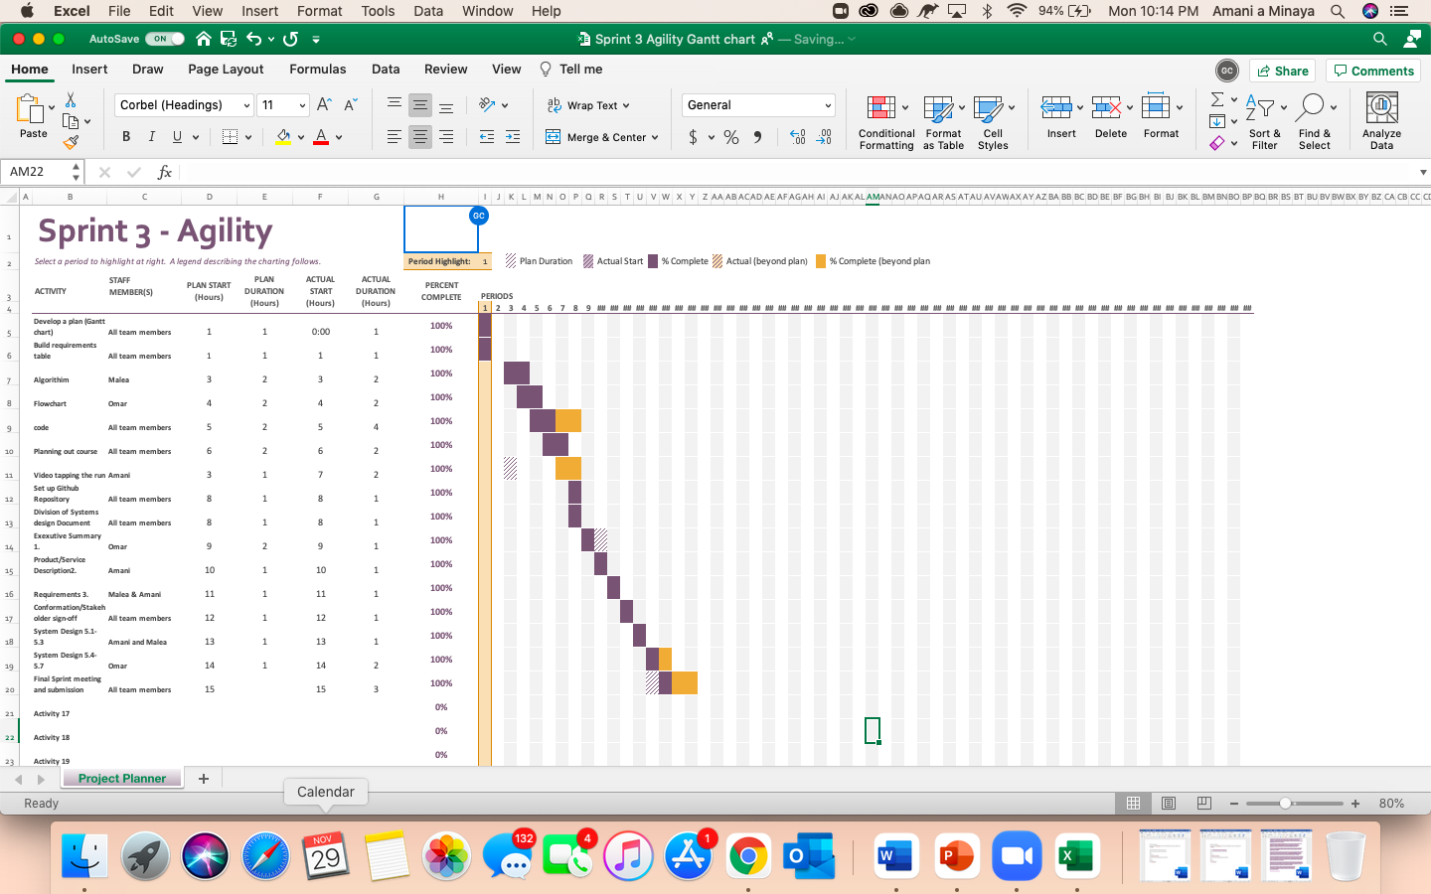

## ***5.7*** ***Staffing Plan***

| Name | Role | Responsibility | Reports To |
| --- | --- | --- | --- |
| Amani Minaya | Organizer,  Videographer,, | Organize algorithm, Organize Gantt chart, Organize powerpoint,  Organize this document. | Malea Horn Attanasio |
| Omar Ahmed | Organizer, | Organize algorithm,  Organize Gantt chart,  Possessed Robot, Organize this document | Malea Horn Attanasio |
| Malea Horn Attanasio | Organizer,  Programmer | Organize algorithm, Organize Gantt chart, Organize powerpoint,  Flowchart, Program code,  Organize this document. |  |